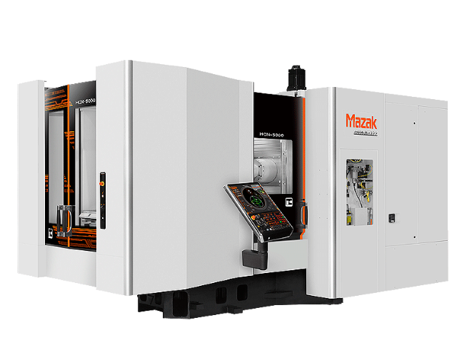

2022 – Mazak HCN 5000
Horizontal Machining Centre
Capacity Pallet Size 19.690 in / 500 mm
Maximum Workpiece Height 39.370 in / 1000 mm
Spindle Spindle Taper Big Plus CAT 40
Maximum Speed 18000 rpm
Magazine Number of Tools 160

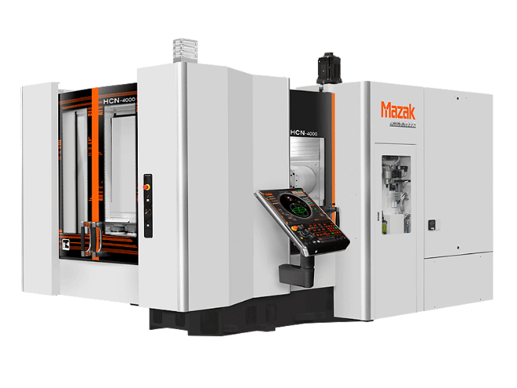

2015 – Mazak Nexus 4000
Model: HCN 4000
Pallet Size: 15.75” x Max. Height: 35.43”
Spindle Taper No 40,
Maximum Speed 18,000 rpm
No. of Tools: 80

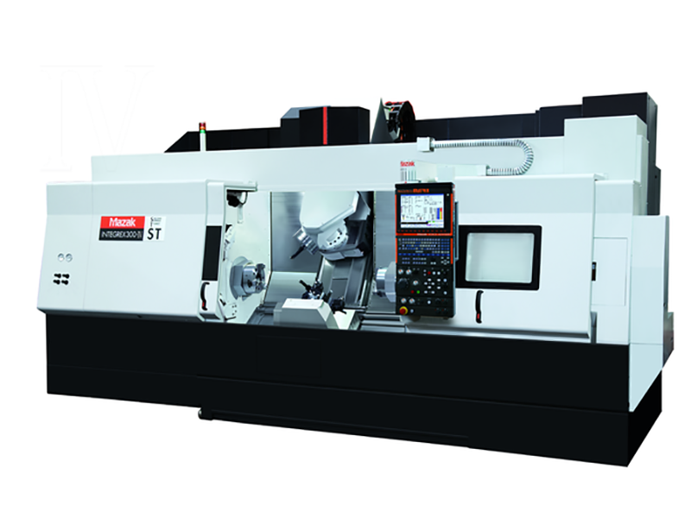

2008 - Mazak – Integrex
Model: 300-4ST 7-axis Lathe
40 tool magazine with automatic tool length measure
12” chuck main spindle, 10” chuck sub spindle
9 station sub turret, 60” maximum length,
24” maximum cutting diameter Full 5-axis capability

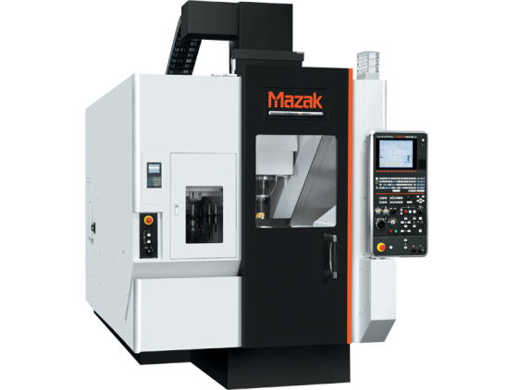

2014 - Mazak – Variaxis 500 – 5X – 2 Pallet
Model: J-500 II 5 – axis Vertical Milling
18,000 RPM spindle (big plus) with coolant through,
30 tool magazine with automatic tool length measure
20” working diameter

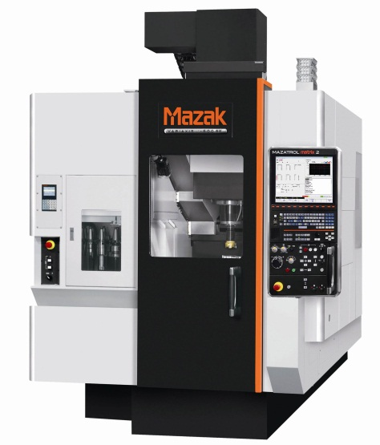

2015 - Mazak – Variaxis 500 – 5X - single pallet
Model: J-500 - 5 – axis Vertical Milling
18,000 RPM spindle (big plus) with coolant through,
30 tool magazine with automatic tool length measure
20” working diameter

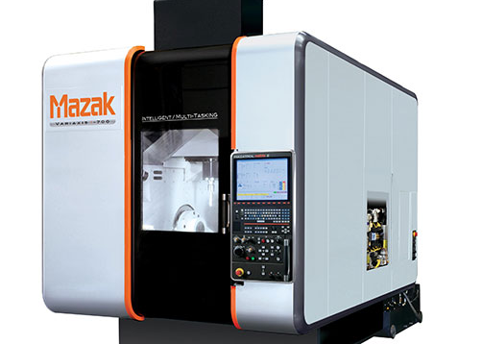

2014 - Mazak – Variaxis I-700
Model: VRX I-700 - 5-axis Vertical Milling
18,000 RPM spindle (big plus) with coolant through
40 tool magazine with automatic tool measure
33” working diameter
Maximum table load - 700 kg

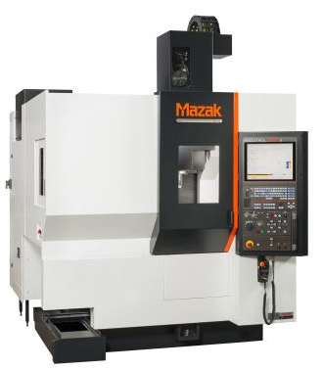
2013 - Mazak - Vertical Center Universal 400A 5X
Model : VCU 400 5X - 5 – axis Vertical Milling
12,000 RPM Spindle
30 tool magazine with automatic tool length measure
16” working diameter

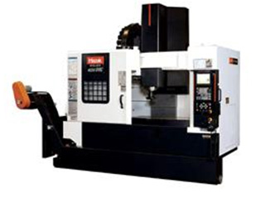

2009 - Mazak – Vertical Centre Nexus
Model: VCN 510C II - with 4-axis
Extended table = 54” x 20”
30 tool magazine with automatic tool length measure
Full force 4-axis capabilities

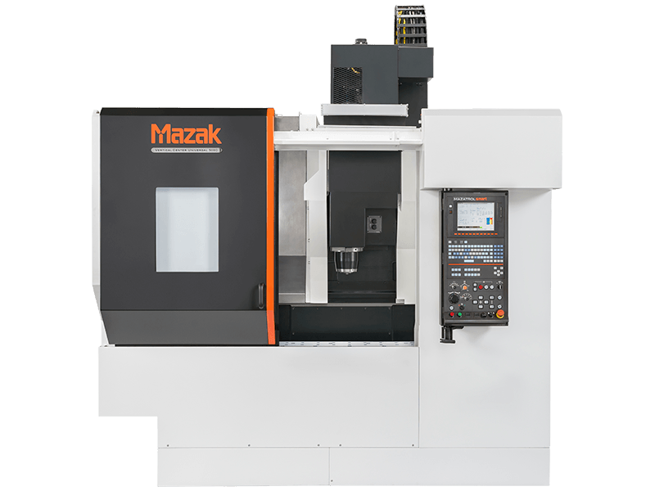

2014 - Mazak – Vertical Universal Milling Centre
Model: VCU 500 C - 4-axis Vertical Milling
Extended Table = 40” x 20”
30 tool magazine with automatic tool length measure
Full force 4-axis capabilities

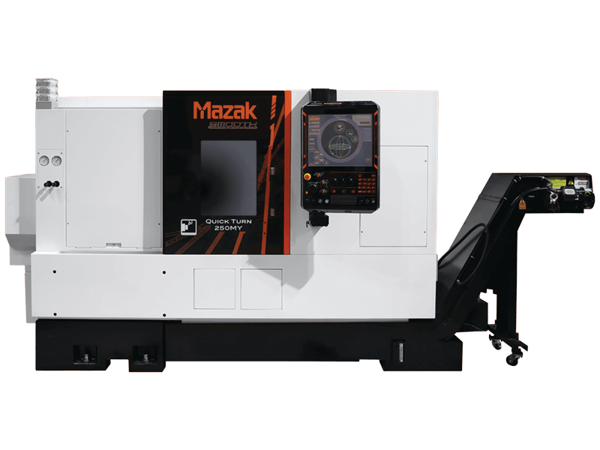

2020 - Mazak Quick turn 250MY , 40”/1000U KY Mazatrol Smoothing Control. Model: QT 250MYE 10” chuck

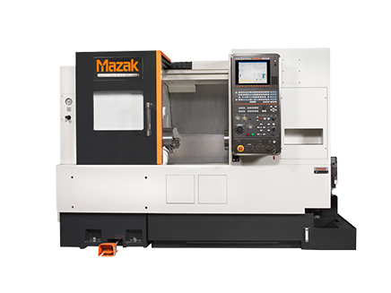

2008 - Mazak – Nexus Turning Milling Machine
Model: QTN 250 MY - 4-axis Lathe
10” chuck, 16” swing, 20” between centre
12 station turret with live tools
Automatic tool length measurement

2008 - Mazak – Vertical Centre Nexus
Model: VCN 510C II - 3-axis Vertical Milling
Extended table = 54” x 20”
30 tool magazine with automatic tool length measure
12,000 RPM Coolant through spindle

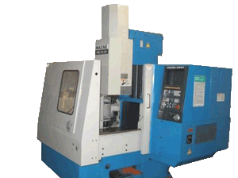

Mazak - Milling Machine – YR - 1989
Model: VQC-15/40 - 3 axis Vertical Milling
Table size: 20” x 16”
6,000 RPM

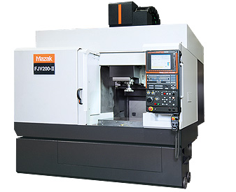
Mazak - Vertical Milling Machine – YR - 1999
Model: FJV 200 - 3 axis Milling Machine
Table Size: 30” x 20”, 30 tool magazine
12,000 RPM Spindle
And
Model: FJV 250
Table Size: 20” x 40”, 42 tool magazine

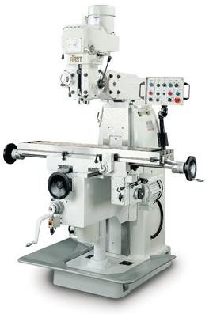

2003 - First Vertical Milling Machine
Model: LC-20 VSG - 3 axis
42” x 12” travel with digital readout and power feed

OTHER:

Mazak – 2 Axis Lathe
Model: QT20 - 2 axis Turning Centre
20” between centres, 12 station tool turret with automatic offset measure
10” chuck, 5,000 RPM

First - Milling Machine
Model: LC-1-1/2 VS
30” x 10” travel with digital readout and power feed

Morton - Manual Lathe
Model: FEL-1340G
8” chuck , 2” through spindle

Hardinge - Manual Lathe, 2-axis
Model: HLV H869

Sunnen Honing Machine

QUALITY CONTROL:

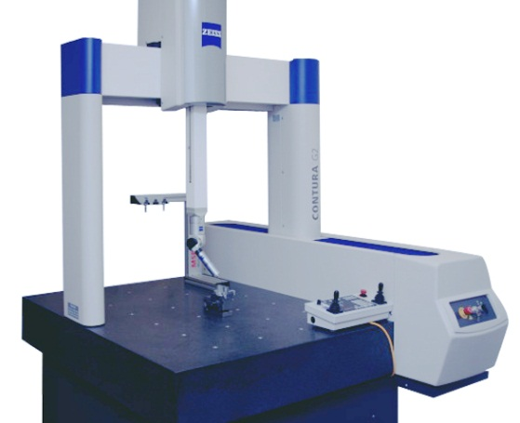

2013 Coordinate Measuring Machine
Model: Zeiss Contura G2
Comes with 22” LCD Monitor
Measuring range: X = 700 mm, Y = 1,000 mm, Z = 600 mm

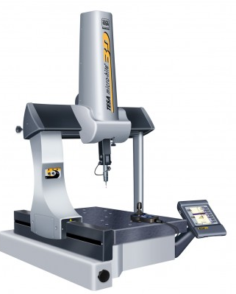

2006 – 3D – Tesastar CMM
Measuring Range: X = 440mm, Y = 490 mm, Z = 390mm
Measuring speed = 13.62 in/sec.
Max part weight = 501 lbs

